**PROGRAM 3. SUPPLIER DATABASE**

Consider the following schema:

SUPPLIERS (sid: integer, sname: string, address: string)

PARTS (pid: integer, pname: string, color: string)

CATALOG (sid: integer, pid: integer, cost: real)

**The Catalog relation lists the prices charged for parts by Suppliers. Write the following queries in SQL:**

CREATE TABLE SUPPLIERS(sid INTEGER PRIMARY KEY, sname VARCHAR(20), address VARCHAR(20));

INSERT INTO suppliers VALUES(10001, 'Acme Widget','Bangalore');

INSERT INTO suppliers VALUES(10002, 'Johns','Kolkata');

INSERT INTO suppliers VALUES(10003, 'Vimal','Mumbai');

INSERT INTO suppliers VALUES(10004, 'Reliance','Delhi');

INSERT INTO suppliers VALUES(10005, 'Mahindra','Mumbai');

SELECT * FROM SUPPLIERS;

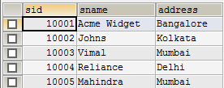

CREATE TABLE PARTS(pid INTEGER PRIMARY KEY, pname VARCHAR(20), color VARCHAR(10));

INSERT INTO PARTS VALUES(20001, 'Book','Red');

INSERT INTO PARTS VALUES(20002, 'Pen','Red');

INSERT INTO PARTS VALUES(20003, 'Pencil','Green');

INSERT INTO PARTS VALUES(20004, 'Mobile','Green');

INSERT INTO PARTS VALUES(20005, 'Charger','Black');

SELECT * FROM PARTS;

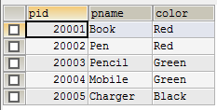

CREATE TABLE CATALOG(sid INTEGER, pid INTEGER, FOREIGN KEY(sid) REFERENCES SUPPLIERS(sid), FOREIGN KEY(pid) REFERENCES PARTS(pid), cost FLOAT(6), PRIMARY KEY(sid, pid));

INSERT INTO CATALOG VALUES(10001, '20001','10');

INSERT INTO CATALOG VALUES(10001, '20002','10');

INSERT INTO CATALOG VALUES(10001, '20003','30');

INSERT INTO CATALOG VALUES(10001, '20004','10');

INSERT INTO CATALOG VALUES(10001, '20005','10');

INSERT INTO CATALOG VALUES(10002, '20001','10');

INSERT INTO CATALOG VALUES(10002, '20002','20');

INSERT INTO CATALOG VALUES(10003, '20003','30');

INSERT INTO CATALOG VALUES(10004, '20003','40');

SELECT * FROM CATALOG;

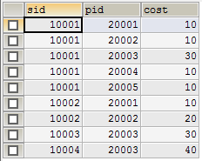

**i. Find the pnames of parts for which there is some supplier.**

SELECT DISTINCT P.pname FROM Parts P, Catalog C WHERE P.pid = C.pid;

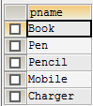

**ii. Find the snames of suppliers who supply every part.**

SELECT S.sname FROM Suppliers S WHERE NOT EXISTS(SELECT P.pid,C.pid FROM Parts P,Catalog C WHERE C.sid = S.sid);



**iii. Find the snames of suppliers who supply every red part.**

SELECT S.sname FROM Suppliers S WHERE EXISTS((SELECT C.pid FROM Catalog C, Parts P WHERE C.sid = S.sid AND C.pid = P.pid AND P.color='red'));



**iv. Find the pnames of parts supplied by Acme Widget Suppliers and by no one else.**

SELECT P.pname FROM Parts P, Catalog C,Suppliers S WHERE P.pid=C.pid AND C.sid=S.sid AND S.sname='Acme Widget' AND NOT EXISTS(SELECT *FROM Catalog C1,Suppliers S1 WHERE P.pid=C1.pid AND C1.sid=S1.sid AND S1.sname <> 'Acme Widget');



**v. Find the sids of suppliers who charge more for some part than the average cost of that part (averaged over**

**all the suppliers who supply that part).**

SELECT DISTINCT C.sid FROM Catalog C WHERE C.cost > ( SELECT AVG (C1.cost)FROM Catalog C1 WHERE C1.pid = C.pid );

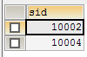

**vi. For each part, find the sname of the supplier who charges the most for that part.**

SELECT P.pid, S.sname FROM Parts P, Suppliers S, Catalog C WHERE C.pid = P.pid AND C.sid = S.sid AND C.cost = (SELECT MAX(C1.cost)FROM Catalog C1 WHERE C1.pid = P.pid );

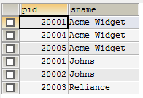

**vii. Find the sids of suppliers who supply only red parts.**

SELECT DISTINCT C.sid FROM Catalog C WHERE NOT EXISTS(SELECT *FROM Parts P WHERE P.pid = C.pid AND P.color <> 'Red');

